Final Resume Description
Smart Log Analyzer
Developed a modular Python application that analyzes server authentication logs, detects suspicious login behavior, identifies brute-force attacks, generates security reports, and exports analytics to CSV and JSON.
Project Architecture
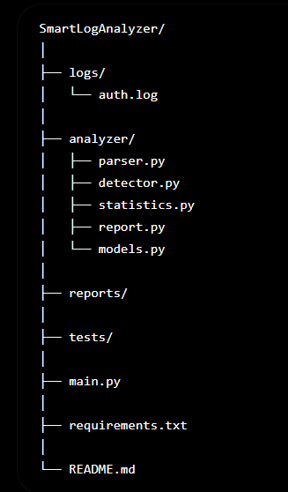
git remote add origin https://github.com/abk69/smart-log-analyzer.git
git branch -M main
git push -u origin main

